**COMSATS University Islamabad,   
Park Road, Chak Shahzad, Islamabad Pakistan**

SOFTWARE DESIGN DESCRIPTION   
(SDD DOCUMENT)

for

**Child Immunization and Growth Tracking System**  
Version 1.0

***By***

**Shariq Ahmed CIIT/SP18-BCS-151/ISB**

**Umar Khalid CIIT/SP18-BCS-164/ISB**

***Supervisor*Dr. Ashfaq Hussain Farooqi**

*Bachelor of Science in Computer Science (2018-2022)*

**Table of Contents**

Contents

1. Introduction 1

2. Design methodology and software process model 1

2.1.1 Process Methodology 1

2.1.2 Design Methodology 1

3. System overview 2

3.1 Architectural design 2

3.1.1 3 tier Architecture 2

3.2 Three Tier Architecture Description 3

3.2.1 Tier-1 3

3.2.2 Tier-2: 3

3.2.3 Tier-3: 3

3.3 Process flow/Representation 3

3.3.1 Activity Diagram for Hospital Module 3

3.3.2 2nd Activity Diagram for Hospital Module 5

3.3.3 Activity Diagram for Admin 6

3.3.4 2nd Acitivity Diagram For Admin 7

3.3.5 Activity Diagram for Vaccine Center Module 8

3.3.6 Activity Diagram For Child Growth And Parent Module 9

3.3.7 Activity Diagram For Polio Worker Module 10

3.3.8 2nd Activity Diagram for Vaccine Center Module 11

4. Design models 12

4.1 Class Diagram 12

4.1.1 Class Diagram For web 12

4.1.2 Class Diagram for Mobile 13

4.2 Sequence Diagram 13

4.2.1 Sequence Diagram For Add Child Data 14

4.2.2 Sequence Diagram For Campaign Creation 15

4.2.3 Sequence Diagram For Child Growth Prediction 16

4.2.4 Sequence Diagram For Child Vaccine Update 17

4.2.5 Sequence Diagram For Predict Vaccine Stock 18

4.2.6 Sequence Diagram For Polio Vaccine update and Symptoms Check 19

5. Data design 20

5.1 ERD 20

5.2 Data dictionary 20

5.2.1 Parent Schema 20

5.2.2 Vaccine Schema 21

5.2.3 User Schema 21

5.2.4 Polio Worker Schema 21

5.2.5 Vaccine Schema 22

5.2.6 Hospital Schema 22

5.2.7 Child Schema 23

5.2.8 Campaign Schema 23

6. Algorithm & Implementation 23

6.1 Implementation 23

6.1.1 Server 23

6.1.2 Campaign Routing 24

6.1.3 Child Routing 25

6.1.4 Vaccine Routing 27

7. Software requirements traceability matrix 28

8. Human interface design 31

8.1 Screen images 31

**Table of Figures**

Figure 1: 3- Tier Architecture 2

Figure 2: Hospital Activity 1 4

Figure 3: Hospital Activity 2 5

Figure 4: Admin Activity 1 6

Figure 5: Admin Activity 2 7

Figure 6: Vaccine Center Activity 1 8

Figure 7: Parent Activity 1 9

Figure 8:Polio Worker Activity 10

Figure 9: Vaccine Center Activity 11

Figure 10: Class Diagram for Web 12

Figure 11: Class Diagram For Mobile 13

Figure 12: Sequence Diagram For Add Child Data 14

Figure 13: Sequence Diagram For Campaign Creation 15

Figure 14: Sequence Diagram For Child Growth Prediction 16

Figure 15: Sequence Diagram For Child Vaccine Update 17

Figure 16: Sequence Diagram For Predict Vaccine Stock 18

Figure 17: Sequence Diagram For Polio Vaccine Update 19

Figure 18: ERD 20

Figure 19: Screen 1 32

Figure 20: Screen 2 33

Figure 21: Screen 3 34

Figure 22: Screen 4 35

Figure 23: Screen 5 35

Revision History

|  |  |  |  |
| --- | --- | --- | --- |
| **Name** | **Date** | **Reason for changes** | **Version** |
|  |  |  |  |
|  |  |  |  |

**Application Evaluation History**

|  |  |
| --- | --- |
| **Comments (by committee)**  **\*include the ones given at scope time both in doc and presentation** | **Action Taken** |
| From where the data about children's and polio teams will be taken. Who will be the owner/Stakeholder of the project that will manage it ? Info about vaccines ? Module 7 will be a building a Data Warehouse for DSS ? Where is the use of AI ? | Children data will be taken by my friend’s hospital  Stakeholders can be government body or any organization under govt.  Info about vaccines means details information about vaccine like whats the purpose of this vaccine, why we use this vaccine etc.  No, we wont build data warehouse. We will not have that much data for a data warehouse.  AI is used in future prediction models |
| The comments previously given is not entertained by the students. Must ensure building data warehouse for decision making system and Where and how to implement AI in the project. | On our communication with Sir Qasim Malik and research, we found out that Data warehouse is not needed in the project as our data is only coming from single source. For DDS, we’ll apply algorithms on the data coming from website or mobile.  For AI implementation, we are building a machine learning model, in which we will add children data regarding growth and skills. Upon that data model will predict about growth. On those results, diets will be suggested. |

Supervised by

Dr. Ashfaq Hussain Farooqi

Signature______________

# Introduction

Child immunization and growth tracking is a system designed to automate the current vaccination system with addition to track the child of growth. Mainly this system is performing these major tasks, i.e., centralizing data of children and parents, managing the vaccination process, growth tracking of child. It will help the authorities to prevent the diseases which are extinct in all over the world. Additionally, it can help the parents to keep an eye on their child health. Following are the modules our system has.

1. Centralizing data
2. Vaccine Center Management
3. User Management
4. Growth Tracking
5. Decision Support System

In this document we are going to explain all the basic structure and designs on which this project will be based on. Following are the points which we have implemented in our 40% submission.

* Front End of all the following points are implemented
* Database is structured and implemented
* Hospital: Centralizing of all data is done which means data of each new child can be enter on the time of birth. Children data can be search by his id or parent and can be viewed.
* Vaccine Center: Vaccine Centers can add or update their stocks. Apart from that, vaccine centers can make new vaccine campaigns and they can allot worker and vaccines to campaigns. Apart from that, they can also monitor their status.

# Design methodology and software process model

### Process Methodology

We are going to use the incremental model in our project. Reasons for choosing an incremental model are

* Our project is long which consists of different modules
* Some modules can be implemented individually
* Requirements of the project are defined and won’t change during development
* So the incremental model suits our project as we can implement different modules and later we can develop and test them.
* In this way, the system will get a test in every possible way and we will get efficient results.

### Design Methodology

We are going to Object Oriented Methodology. Reason for using OOP methodology is

* System can be decomposed in smaller parts components which makes management easy
* Communication between components become easy
* System becomes understandable and less complex which makes implementation easy
* System can be easily modified if required

# System overview

Child Vaccination and growth has been a major problem of our health care system. Looking at the stats we come to know that we are only one of 2 countries who are having polio problem. Reason is that data is not centralized and its difficult to track vaccination and growth manually. In rural areas, some uneducated people thinks these vaccinations are dangerous for their child and that’s why they don’t get their children vaccinated. Due to this mortality rate increases. 66 out of 1000 children dies every year and major causes of these stats and unvaccinated and untracked growth of children

Child immunization will help the authorities to centralize the children data. And later they can track the vaccination automatically. On birth of child, his data will be entered in the system that will generate vaccination dates. Before vaccination date, parent will get reminder messages. If any children don’t get vaccinated they will get reminder messages, and later on unvaccinated child data will be send to higher authorities. In this way it will help to track the children who are still unvaccinated.

Growth module is for parents to keep check on the health of their children. They can enter data into the system time to time and system on basis of data will give results on it. They can see suggested diet too.

## Architectural design

### 3 tier Architecture

Figure 1: 3- Tier Architecture

## Three Tier Architecture Description

### Tier-1

This is the front end of the system where user can access all the functionalities using the interface. It is usually called as Presentation Layer. This layer is implemented in React and React Native.

### Tier-2:

This is the backend of the system where all the application logic is implemented. It is a server which make communication between tier 1 and tier 3. This layer is called as Business Layer. It is implemented in Node JS.

### Tier-3:

This is the database of the system where all the application data will be stored. This layer is called as Data Layer. It is implemented Mongo DB.

## Process flow/Representation

### Activity Diagram for Hospital Module

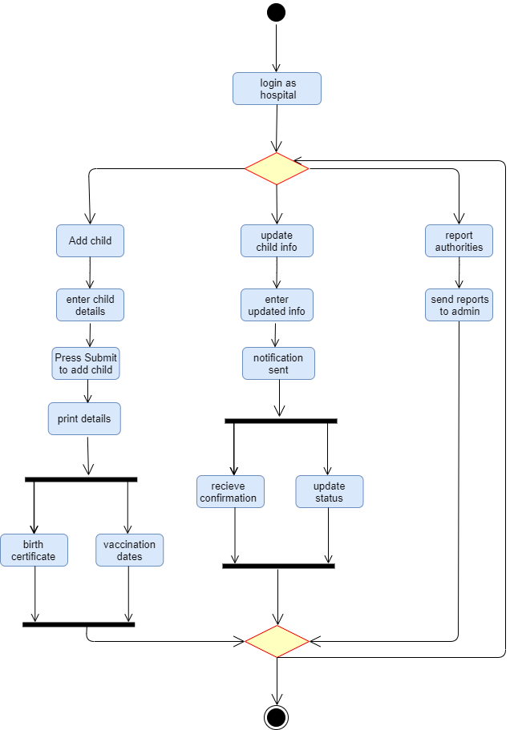

Figure 2: Hospital Activity 1

### 2nd Activity Diagram for Hospital Module

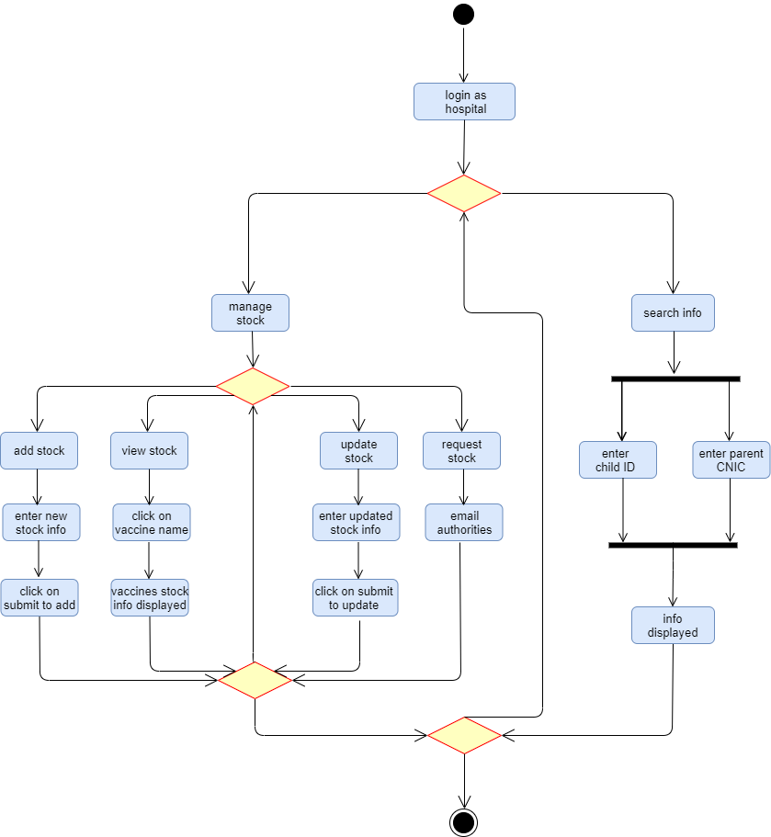

Figure 3: Hospital Activity 2

### Activity Diagram for Admin

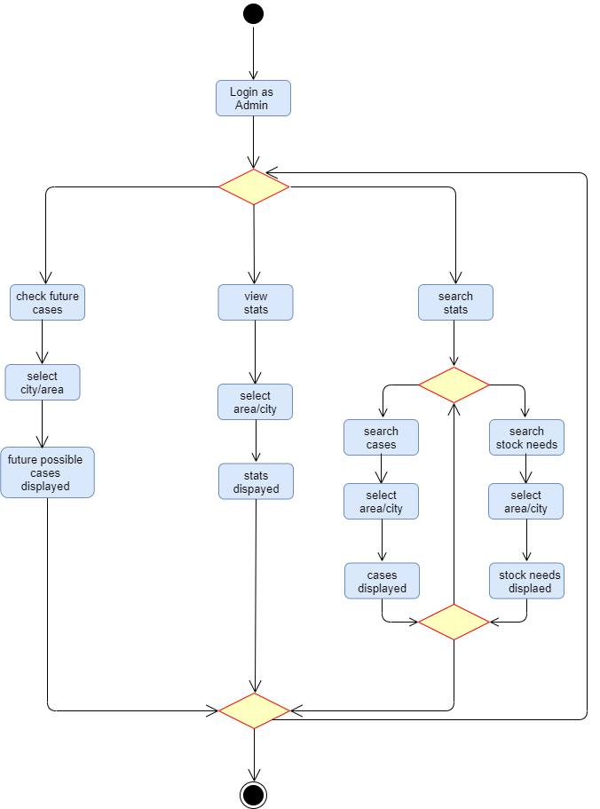

Figure 4: Admin Activity 1

### 2nd Acitivity Diagram For Admin

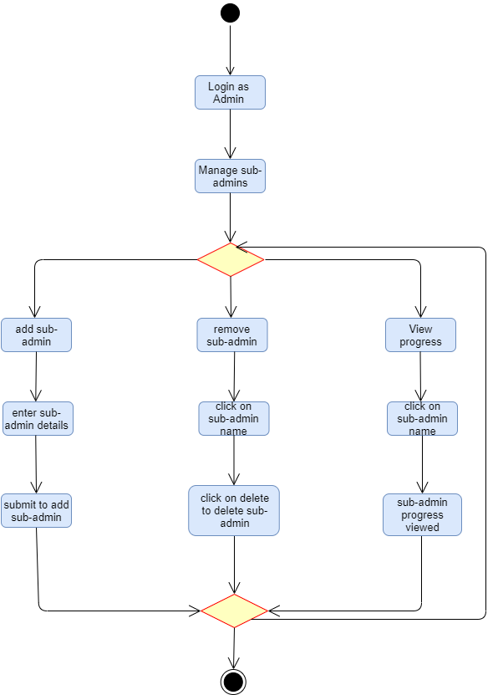

Figure 5: Admin Activity 2

### Activity Diagram for Vaccine Center Module

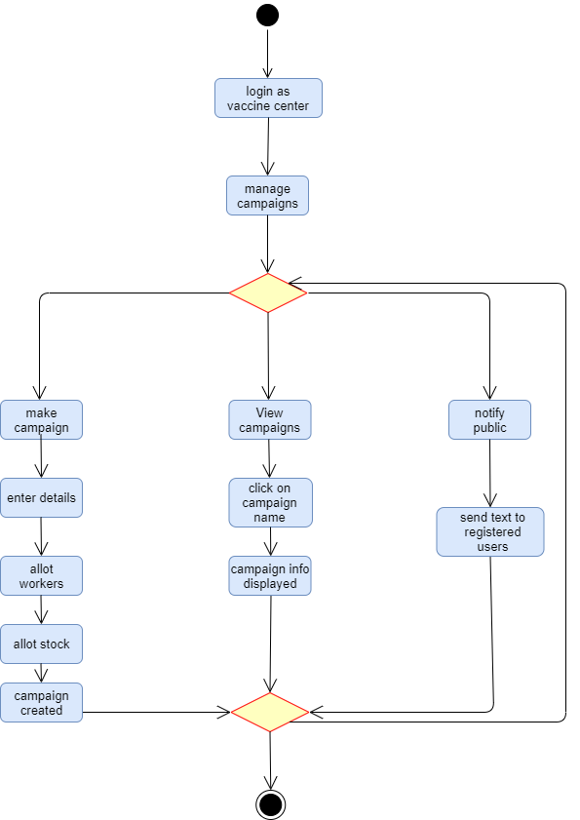

Figure 6: Vaccine Center Activity 1

### Activity Diagram For Child Growth And Parent Module

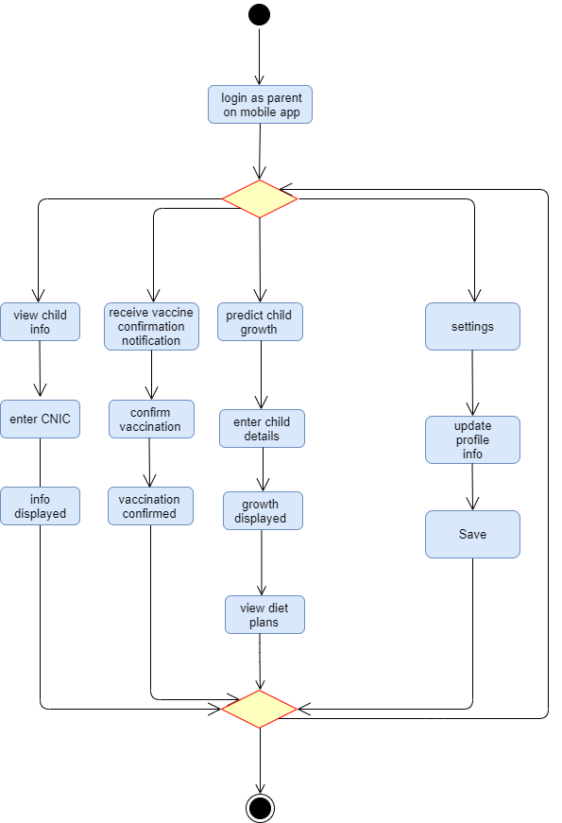

Figure 7: Parent Activity 1

### Activity Diagram For Polio Worker Module

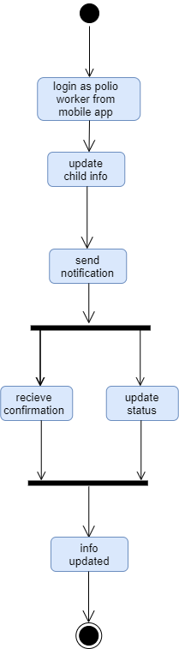

Figure 8:Polio Worker Activity

### 2nd Activity Diagram for Vaccine Center Module

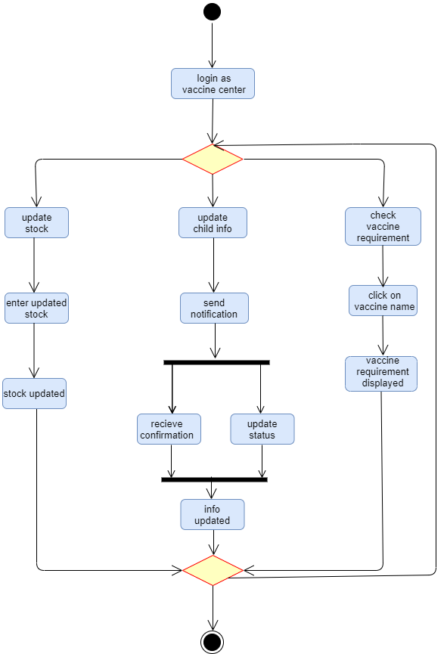

Figure 9: Vaccine Center Activity

# Design models

## Class Diagram

### Class Diagram For web

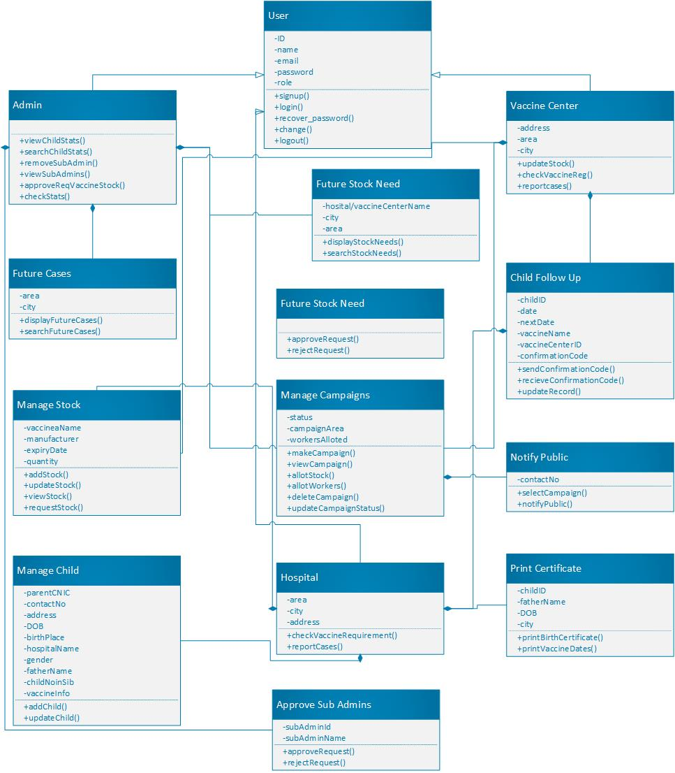

Figure 10: Class Diagram for Web

### Class Diagram for Mobile

Figure 11: Class Diagram For Mobile

## Sequence Diagram

### Sequence Diagram For Add Child Data

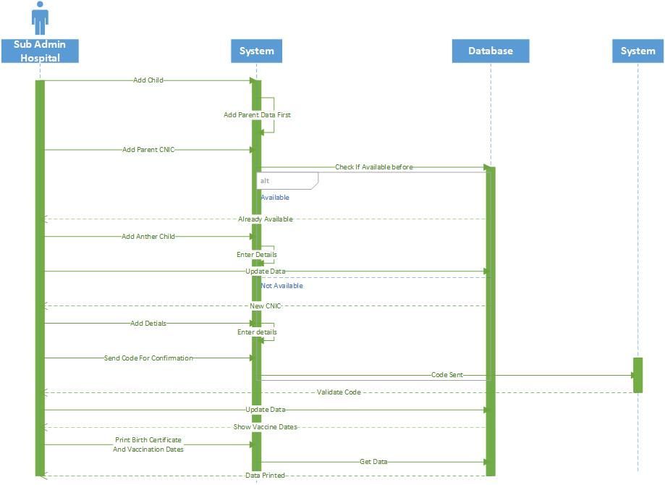

Figure 12: Sequence Diagram For Add Child Data

### Sequence Diagram For Campaign Creation

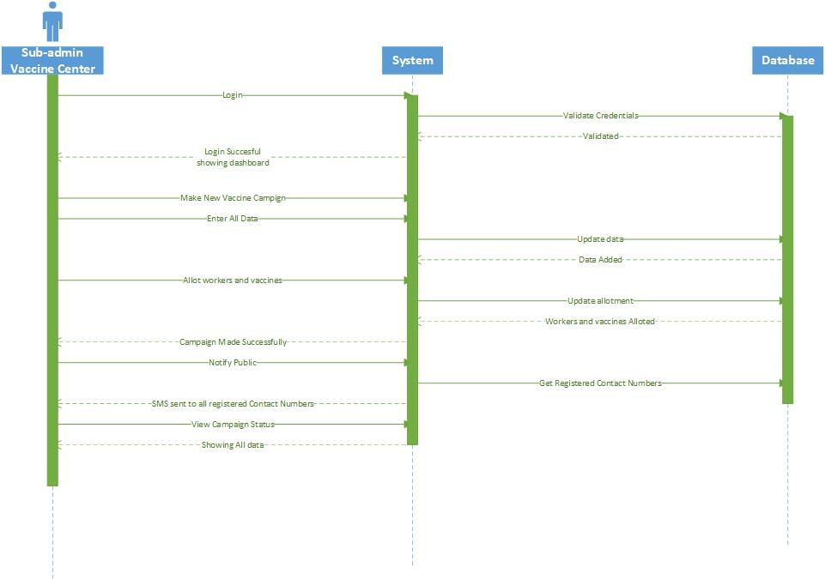

Figure 13: Sequence Diagram For Campaign Creation

### Sequence Diagram For Child Growth Prediction

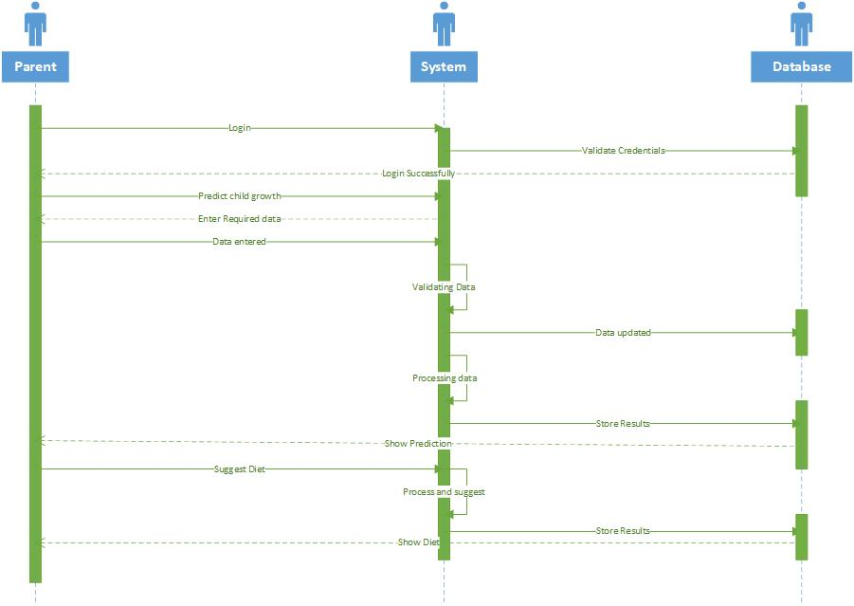

Figure 14: Sequence Diagram For Child Growth Prediction

### Sequence Diagram For Child Vaccine Update

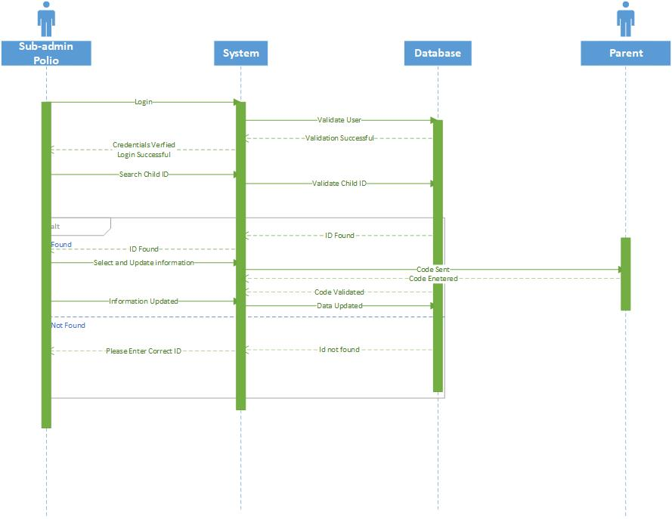

Figure 15: Sequence Diagram For Child Vaccine Update

### Sequence Diagram For Predict Vaccine Stock

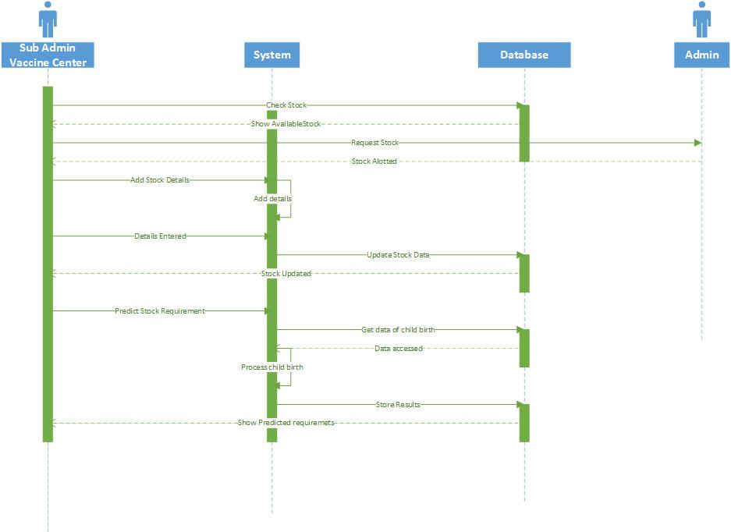

Figure 16: Sequence Diagram For Predict Vaccine Stock

### Sequence Diagram For Polio Vaccine update and Symptoms Check

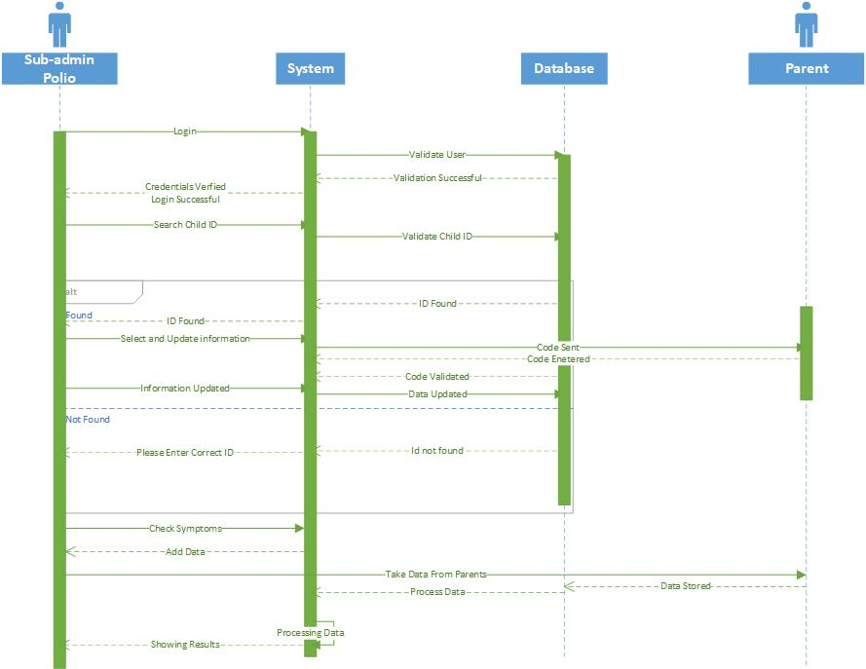

Figure 17: Sequence Diagram For Polio Vaccine Update

# Data design

## ERD

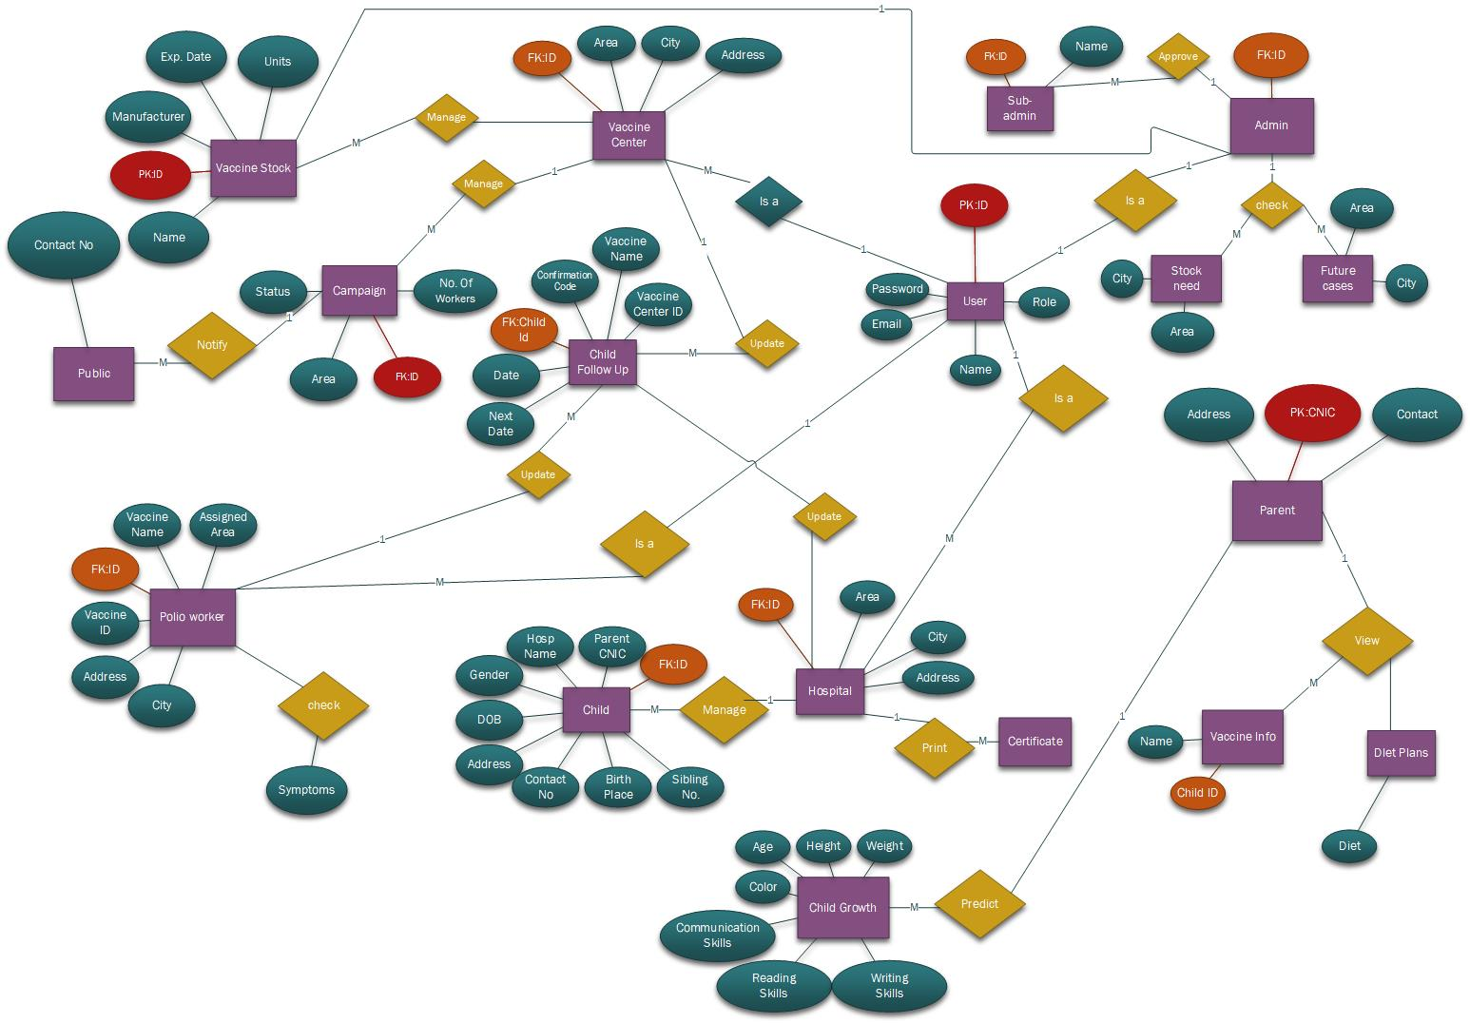ERD for Full System

Figure 18: ERD

## Data dictionary

### Parent Schema

const parentSchema = new Schema(  
 {  
 parentID: { type: ***String***, default: "vaccine center", required: true },  
 role: {  
 type: ***String***,  
 default: "parent",  
 required: true,  
 enum: ["vaccine center", "hospital", "parent", "polio worker"],  
 },  
 name: { type: ***String***, default: "", required: true },  
 email: { type: ***String***, default: "", required: true },  
 password: { type: ***String***, default: "", required: true },  
 contactNo: { type: ***String***, required: true, default: "" },  
 address: { type: ***String***, required: true, default: "" },  
 cnic: { type: ***String***, required: true, default: "" },  
 },  
 {  
 timestamps: true,  
 }  
);

### Vaccine Schema

const vaccineSchema = new Schema(  
 {  
 vaccineID: { type: ***String***, default: "", required: true },  
 name: { type: ***String***, default: "", required: true, enum: ["active", "inactive"] },  
 manufacturer: { type: ***String***, default: "", required: true },  
 quantity: { type: ***Number***, default: 50, required: true },  
 expiryDate: { type: ***Date***, default: ***Date***.now, required: true },  
 },  
 {  
 timestamps: true,  
 }  
);

### User Schema

const userSchema = new Schema(  
 {  
 userID: { type: ***String***, default: "", required: true },  
 role: {  
 type: ***String***,  
 default: "",  
 required: true,  
 enum: ["vaccine center", "hospital", "parent", "polio worker"],  
 },  
 name: { type: ***String***, default: "", required: true },  
 email: { type: ***Number***, default: 5, required: true },  
 password: { type: ***Date***, default: ***Date***.now },  
 },  
 {  
 timestamps: true,  
 }  
);

### Polio Worker Schema

const polioWorkerSchema = new Schema(  
 {  
 workerID: { type: ***String***, default: "vaccine center", required: true },  
 role: {  
 type: ***String***,  
 default: "polio worker",  
 required: true,  
 enum: ["vaccine center", "hospital", "parent", "polio worker"],  
 },  
 name: { type: ***String***, default: "", required: true },  
 email: { type: ***String***, default: "", required: true },  
 password: { type: ***String***, default: "", required: true },  
 contactNo: { type: ***String***, required: true, default: "" },  
 city: { type: ***String***, required: true, default: "" },  
 assignedArea: { type: ***String***, required: true, default: "" },  
 vaccineCenter: { type: ***String***, required: true, default: "" },  
 },  
 {  
 timestamps: true,  
 }  
);

### Vaccine Schema

const vaccineSchema = new Schema(  
 {  
 vaccineID: { type: ***String***, default: "", required: true },  
 name: { type: ***String***, default: "", required: true, enum: ["active", "inactive"] },  
 manufacturer: { type: ***String***, default: "", required: true },  
 quantity: { type: ***Number***, default: 50, required: true },  
 expiryDate: { type: ***Date***, default: ***Date***.now, required: true },  
 },  
 {  
 timestamps: true,  
 }  
);

### Hospital Schema

const hospitalSchema = new Schema(  
 {  
 hospitalID: { type: ***String***, default: "hospital", required: true },  
 role: {  
 type: ***String***,  
 default: "",  
 required: true,  
 enum: ["vaccine center", "hospital", "parent", "polio worker"],  
 },  
 name: { type: ***String***, default: "", required: true },  
 email: { type: ***String***, default: "", required: true },  
 password: { type: ***String***, default: "", required: true },  
 area: { type: ***String***, default: "", required: true },  
 city: { type: ***String***, default: "", required: true },  
 address: { type: ***String***, default: "", required: true },  
 },  
 {  
 timestamps: true,  
 }  
);

### Child Schema

const childSchema = new Schema(  
 {  
 childID: { type: ***String***, required: true, default: "" },  
 parentName: { type: ***String***, required: true, default: "" },  
 parentCNIC: { type: ***String***, required: true, default: "" },  
 contactNo: { type: ***String***, required: true, default: "" },  
 address: { type: ***String***, required: true, default: "" },  
 dateOfBirth: { type: ***Date***, required: true, default: "" },  
 gender: { type: ***String***, required: true, default: "" },  
 birthPlace: { type: ***String***, required: true, default: "" },  
 siblingNo: { type: ***Number***, required: true, default: "" },  
 hospitalName: { type: ***String***, required: true, default: "" },  
 vaccinationInfo: { type: ***String***, default: "" },  
 },  
 {  
 timestamps: true,  
 }  
);

### Campaign Schema

const campaignSchema = new Schema(  
 {  
 campaignID: { type: ***String***, default: "", required: true },  
 status: { type: ***String***, default: "active", required: true, enum: ["active", "inactive"] },  
 area: { type: ***String***, default: "", required: true },  
 noOfWorkers: { type: ***Number***, default: 5, required: true },  
 startDate: { type: ***Date***, default: ***Date***.now },  
 endDate: { type: ***Date***, default: ***Date***.now },  
 },  
 {  
 timestamps: true,  
 }  
);

# Algorithm & Implementation

## Implementation

### Server

const express = require("express"),  
 cors = require("cors"),  
 mongoose = require("mongoose");  
  
require("dotenv").config();  
  
const app = express();  
const PORT = process.env.PORT || 5000;  
  
app.use(cors());  
app.use(express.json());  
  
// db connection  
const ATLAS_URI = process.env.ATLAS_URI;  
mongoose.connect(ATLAS_URI, {  
 useNewUrlParser: true,  
 useCreateIndex: true,  
 useUnifiedTopology: true,  
});  
  
const connection = mongoose.connection;  
connection.once("open", () => {  
 console.log(`Mongodb connected successfully`);  
});  
  
// routers  
const childRouter = require("./routes/children");  
const vaccineRouter = require("./routes/vaccines");  
const campaignRouter = require("./routes/campaigns");  
  
app.use("/children", childRouter);  
app.use("/vaccines", vaccineRouter);  
app.use("/campaigns", campaignRouter);  
  
// start server  
app.listen(PORT, () => {  
 console.log(`Server is running at ${PORT}`);  
});

### Campaign Routing

const ***router*** = require("express").Router();  
let ***Campaign*** = require("../models/Campaign.model");  
  
// get Campaigns  
***router***.route("/").get((req, res) => {  
 ***Campaign***.find()  
 .then((campaign) => res.json(campaign))  
 .catch((err) => res.status(400).json({ error: err }));  
});  
  
// get single Campaign  
***router***.route("/:id").get((req, res) => {  
 ***Campaign***.findById(req.params.id)  
 .then((campaign) => res.json(campaign))  
 .catch((err) => res.status(400).json({ error: err }));  
});  
  
// delete Campaign  
***router***.route("/:id").delete((req, res) => {  
 ***Campaign***.findByIdAndDelete(req.params.id)  
 .then((campaign) => res.json("Campaign deleted "))  
 .catch((err) => res.status(400).json({ error: err }));  
});  
  
// add Campaign  
***router***.route("/add").post((req, res) => {  
 const campaignID = req.body.campaignID;  
 const status = req.body.status;  
 const area = req.body.area;  
 const noOfWorkers = ***Number***(req.body.noOfWorkers);  
 const startDate = ***Date***.parse(req.body.startDate);  
 const endDate = ***Date***.parse(req.body.endDate);  
  
 const newCampaign = new ***Campaign***({  
 campaignID,  
 status,  
 area,  
 noOfWorkers,  
 startDate,  
 endDate,  
 });  
  
 newCampaign  
 .save()  
 .then(() => res.json("Campaign added!"))  
 .catch((err) => res.status(400).json({ error: err }));  
});  
  
// update Campaign  
***router***.route("/update/:id").post((req, res) => {  
 ***Campaign***.findById(req.params.id)  
 .then((campaign) => {  
 campaign.campaignID = req.body.campaignID;  
 campaign.status = req.body.status;  
 campaign.area = req.body.area;  
 campaign.noOfWorkers = ***Number***(req.body.noOfWorkers);  
 campaign.startDate = ***Date***.parse(req.body.startDate);  
 campaign.endDate = ***Date***.parse(req.body.endDate);  
  
 campaign  
 .save()  
 .then(() => res.json("Campaign updated!"))  
 .catch((err) => res.status(400).json({ error: err }));  
 })  
 .catch((err) => res.status(400).json({ error: err }));  
});  
  
module.exports = ***router***;

### Child Routing

const ***router*** = require("express").Router();  
let ***Child*** = require("../models/child.model");  
  
// get children  
***router***.route("/").get((req, res) => {  
 ***Child***.find()  
 .then((children) => res.json(children))  
 .catch((err) => res.status(400).json({ error: err }));  
});  
  
// get single child  
***router***.route("/:id").get((req, res) => {  
 ***Child***.findById(req.params.id)  
 .then((children) => res.json(children))  
 .catch((err) => res.status(400).json({ error: err }));  
});  
  
// delete child  
***router***.route("/:id").delete((req, res) => {  
 ***Child***.findByIdAndDelete(req.params.id)  
 .then((children) => res.json("Child deleted "))  
 .catch((err) => res.status(400).json({ error: err }));  
});  
  
// add child  
***router***.route("/add").post((req, res) => {  
 const childID = req.body.childID;  
 const parentName = req.body.parentName;  
 const parentCNIC = req.body.parentCNIC;  
 const contactNo = req.body.contactNo;  
 const address = req.body.address;  
 const dateOfBirth = ***Date***.parse(req.body.dateOfBirth);  
 const gender = req.body.gender;  
 const birthPlace = req.body.birthPlace;  
 const siblingNo = ***Number***(req.body.siblingNo);  
 const hospitalName = req.body.hospitalName;  
 const vaccinationInfo = req.body.vaccinationInfo;  
  
 const newChild = new ***Child***({  
 childID,  
 parentName,  
 parentCNIC,  
 contactNo,  
 address,  
 dateOfBirth,  
 gender,  
 birthPlace,  
 siblingNo,  
 hospitalName,  
 vaccinationInfo,  
 });  
  
 newChild  
 .save()  
 .then(() => res.json("Child added!"))  
 .catch((err) => res.status(400).json({ error: err }));  
});  
  
// update child  
***router***.route("/update/:id").post((req, res) => {  
 ***Child***.findById(req.params.id)  
 .then((child) => {  
 child.childID = req.params.childID;  
 child.parentName = req.body.parentName;  
 child.parentCNIC = req.body.parentCNIC;  
 child.childID = req.body.childID;  
 child.contactNo = req.body.contactNo;  
 child.address = req.body.address;  
 child.dateOfBirth = ***Date***.parse(req.body.dateOfBirth);  
 child.gender = req.body.gender;  
 child.birthPlace = req.body.birthPlace;  
 child.siblingNo = ***Number***(req.body.siblingNo);  
 child.hospitalName = req.body.hospitalName;  
 child.vaccinationInfo = req.body.vaccinationInfo;  
  
 child  
 .save()  
 .then(() => res.json("Child updated!"))  
 .catch((err) => res.status(400).json({ error: err }));  
 })  
 .catch((err) => res.status(400).json({ error: err }));  
});  
  
module.exports = ***router***;

### Vaccine Routing

const ***router*** = require("express").Router();  
let ***Vaccine*** = require("../models/Vaccine.model");  
  
// get Vaccines  
***router***.route("/").get((req, res) => {  
 ***Vaccine***.find()  
 .then((vaccine) => res.json(vaccine))  
 .catch((err) => res.status(400).json({ error: err }));  
});  
  
// get single Vaccine  
***router***.route("/:id").get((req, res) => {  
 ***Vaccine***.findById(req.params.id)  
 .then((vaccine) => res.json(vaccine))  
 .catch((err) => res.status(400).json({ error: err }));  
});  
  
// delete Vaccine  
***router***.route("/:id").delete((req, res) => {  
 ***Vaccine***.findByIdAndDelete(req.params.id)  
 .then((vaccine) => res.json("Vaccine deleted "))  
 .catch((err) => res.status(400).json({ error: err }));  
});  
  
// add Vaccine  
***router***.route("/add").post((req, res) => {  
 const vaccineID = req.body.vaccineID;  
 const name = req.body.name;  
 const manufacturer = req.body.manufacturer;  
 const quantity = ***Number***(req.body.quantity);  
 const expiryDate = ***Date***.parse(req.body.expiryDate);  
  
 const newVaccine = new ***Vaccine***({  
 vaccineID,  
 name,  
 manufacturer,  
 quantity,  
 expiryDate,  
 });  
  
 newVaccine  
 .save()  
 .then(() => res.json("Vaccine added!"))  
 .catch((err) => res.status(400).json({ error: err }));  
});  
  
// update Vaccine  
***router***.route("/update/:id").post((req, res) => {  
 ***Vaccine***.findById(req.params.id)  
 .then((vaccine) => {  
 vaccine.vaccineID = req.body.vaccineID;  
 vaccine.name = req.body.name;  
 vaccine.manufacturer = req.body.manufacturer;  
 vaccine.quantity = ***Number***(req.body.quantity);  
 vaccine.expiryDate = ***Date***.parse(req.body.expiryDate);  
  
 vaccine  
 .save()  
 .then(() => res.json("Vaccine updated!"))  
 .catch((err) => res.status(400).json({ error: err }));  
 })  
 .catch((err) => res.status(400).json({ error: err }));  
});  
  
module.exports = ***router***;

# Software requirements traceability matrix

Table 1 Requirements Traceability Matrix

|  |  |  |  |
| --- | --- | --- | --- |
| **Req. Number** | **Ref. Item** | **Design Component** | **Component Items** |
| FR01 | Class Diagram | Admin | InputInformation |
| FR02 | Class Diagram | Admin | Prediction |
| FR03 | Class Diagram | Admin | Predict Vaccine Stock |
| FR04 | Class Diagram | Admin | Predict future cases |
| FR05 | Class Diagram | Admin | Predict future cases by city, area |
| FR06 | Class Diagram | Admin | Predict future stock needs by city, area |
| FR07 | Class Diagram | Admin | View Stats |
| FR08 | Class Diagram | Admin | View Stats by city/area |
| FR09 | Class Diagram | Admin | Search Stats |
| FR10 | Class Diagram | Admin | Search Stock by city/area |
| FR11 | Class Diagram | Admin | Search Cases by city/area |
| FR12 | Class Diagram | Admin | Search child info |
| FR13 | Class Diagram | Admin | Manage sub admins |
| FR14 | Class Diagram | Admin | Add sub admin |
| FR15 | Class Diagram | Admin | Remove sub admin |
| FR16 | Class Diagram | Admin | View sub admin progress |
| FR17 | Class Diagram | Parent | Fill information |
| FR18 | Class Diagram | Parent | Input information |
| FR19 | Class Diagram | Parent | Click on View child details |
| FR20 | Class Diagram | Parent | Enter child ID |
| FR21 | Class Diagram | Parent | Receive notifications |
| FR22 | Class Diagram | Parent | Confirm vaccinations |
| FR23 | Class Diagram | Parent | Check child growth |
| FR24 | Class Diagram | Parent | Fill information |
| FR25 | Class Diagram | Parent | Submit Information |
| FR26 | Class Diagram | Parent | View suggested diet |
| FR27 | Class Diagram | Parent | Update settings |
| FR28 | Class Diagram | Parent | Update password |
| FR29 | Class Diagram | Parent | Update child record |
| FR30 | Class Diagram | Parent | Enter Symptoms |
| FR31 | Class Diagram | Parent | Check Polio Symptoms |
| FR32 | Class Diagram | Parent | See Results |
| FR33 | Class Diagram | Polio Worker | Send notifications |
| FR34 | Class Diagram | Polio Worker | Receive confirmation |
| FR35 | Class Diagram | Polio Worker | Update status |
| FR36 | Class Diagram | Polio Worker | Enter Symptoms |
| FR37 | Class Diagram | Polio Worker | Check Polio Symptoms |
| FR38 | Class Diagram | Polio Worker | See Results |
| FR39 | Class Diagram | Polio Worker | Report Cases |
| FR40 | Class Diagram | Hospital, Vaccination center | Sign up from web app. |
| FR41 | Class Diagram | Hospital, Vaccination center | Enter Information |
| FR42 | Class Diagram | Hospital, Vaccination center | Login |
| FR43 | Class Diagram | Hospital | add child record |
| FR44 | Class Diagram | Hospital | Enter child details |
| FR45 | Class Diagram | Hospital | Submit child record |
| FR46 | Class Diagram | Hospital, Vaccination center | Sent Confirmation |
| FR47 | Class Diagram | Hospital, Vaccination center | Receive Confirmation |
| FR48 | Class Diagram | Hospital, Vaccination center | update child record |
| FR49 | Class Diagram | Hospital, Vaccination center | Search ID |
| FR50 | Class Diagram | Hospital, Vaccination center | Submit updated child record |
| FR51 | Class Diagram | Hospital | print birth certificate |
| FR52 | Class Diagram | Hospital | Adjust print options |
| FR53 | Class Diagram | Hospital | print vaccination dates |
| FR54 | Class Diagram | Hospital, Vaccination center | Search child information |
| FR55 | Class Diagram | Hospital, Vaccination center | Check vaccine requirements |
| FR56 | Class Diagram | Hospital, Vaccination center | Update child vaccination record |
| FR57 | Class Diagram | Hospital, Vaccination center | Report authorities |
| FR58 | Class Diagram | Hospital, Vaccination center | Manage vaccine stock |
| FR59 | Class Diagram | Hospital, Vaccination center | Add stock |
| FR60 | Class Diagram | Hospital, Vaccination center | update stock |
| FR61 | Class Diagram | Hospital, Vaccination center | View stock |
| FR62 | Class Diagram | Hospital, Vaccination center | Request for stock |
| FR63 | Class Diagram | Vaccination center | Manage campaigns |
| FR64 | Class Diagram | Vaccination center | Make new campaigns |
| FR65 | Class Diagram | Vaccination center | View campaign status |
| FR66 | Class Diagram | Vaccination center | Allot workers for campaign |
| FR67 | Class Diagram | Vaccination center | Notify public |

# Human interface design

Describe the functionality of the system from the user’s perspective. Explain how the user will be able  to use  your system to complete  all the  expected  features and  the  feedback  information that will be displayed for the user.

## Screen images

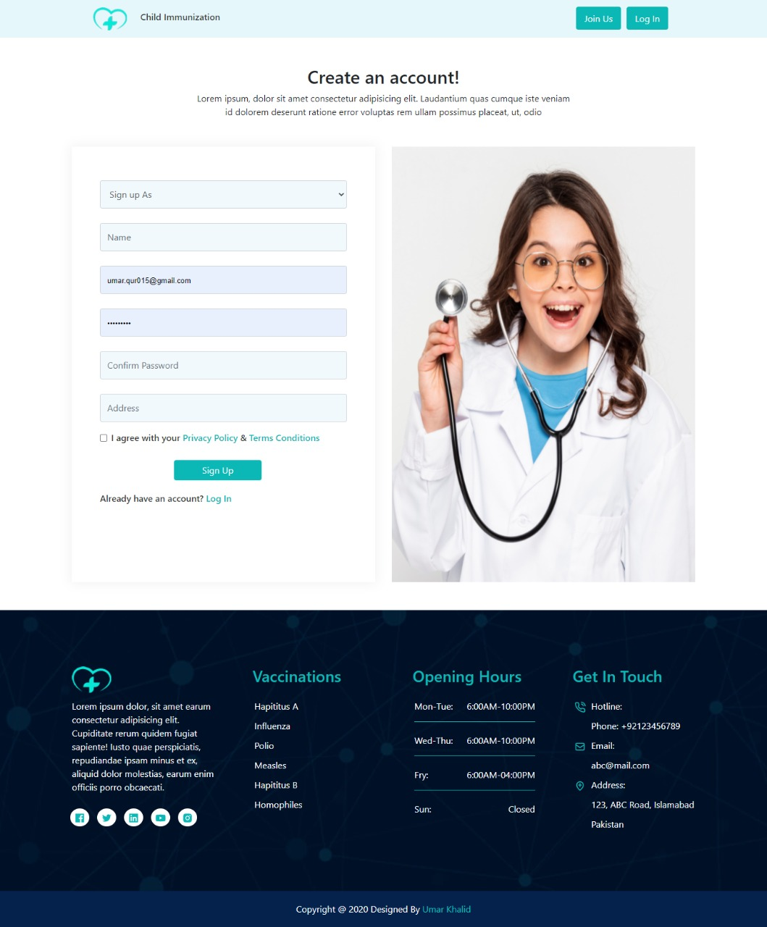Figure 19: Screen 1

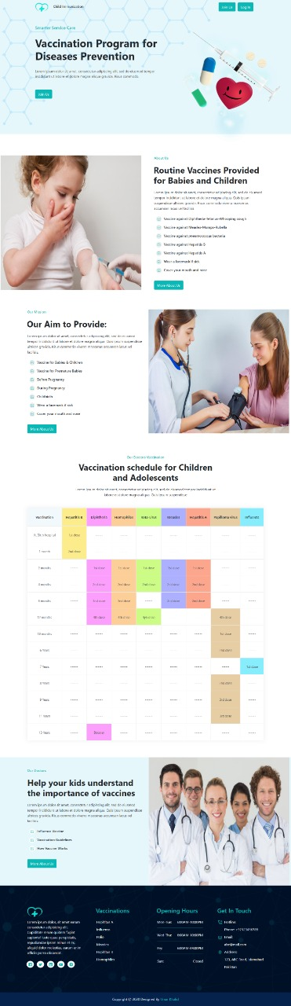

Figure 20: Screen 2

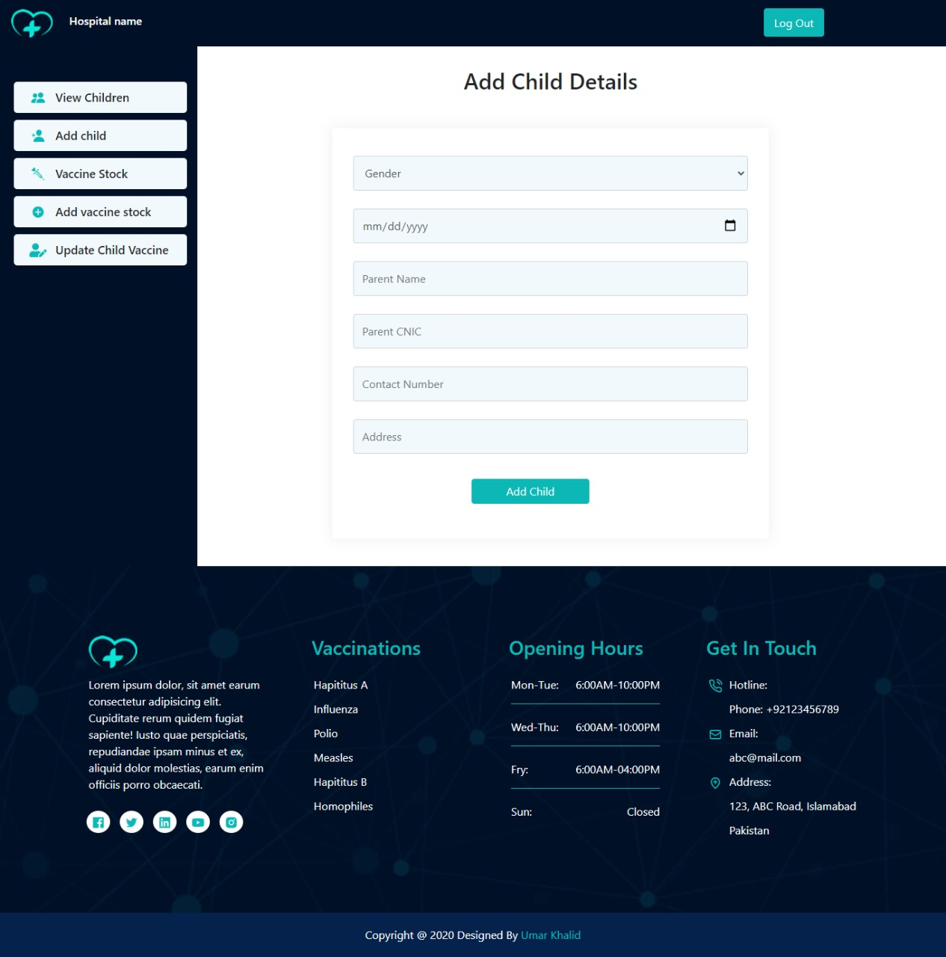Figure 21: Screen 3

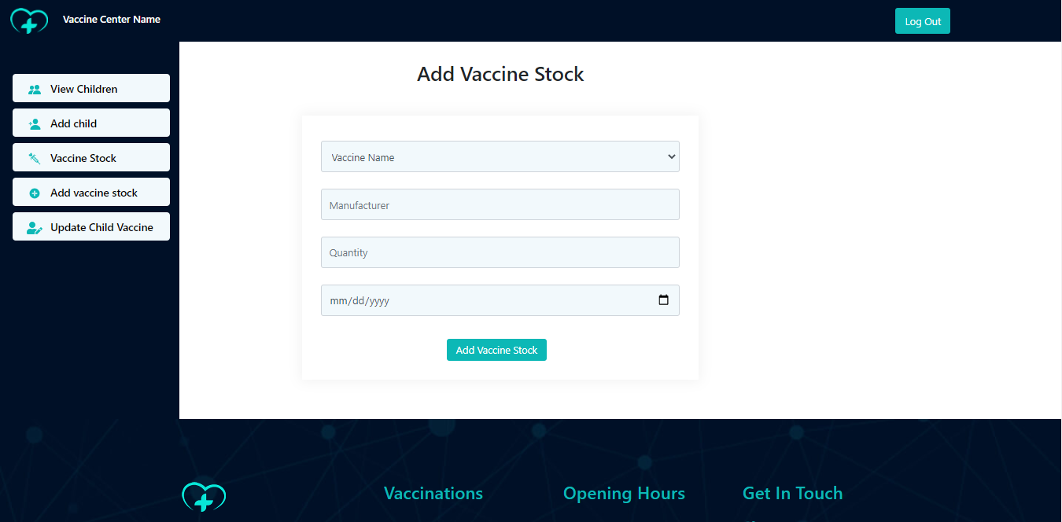

Figure 22: Screen 4



Figure 23: Screen 5